CI – Continuous Integration

CD – Continuous Delivery

DevOps – DEVelopment & OPerationS.

DevSecOps – DEVelopment, SECurity & OPerationS.

DevOps Tools

1. Docker – Containerization Tool
2. Kubernetes – Container Orchestration Tool
3. Jenkins – Auto Build, Test, Containerize Tool
4. Chef, Puppet etc.,

Docker & Kubernetes

Docker – <https://www.docker.com>

Docker Client – Docker Desktop (github desktop client)

Docker Hub – hub.docker.com (github)

Virtualization & Hyper-V (Enable it in OS/BIOS Level)

Search for “Turn Windows Feature On/Off”

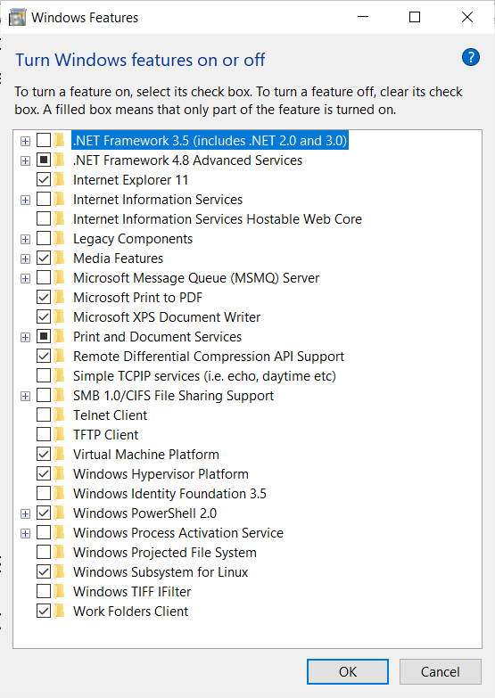

Docker desktop client --- <https://www.docker.com/get-started>

Docker - Light weight Virtual Machine

Virtual Machine –

Base Operating System – (Windows/ Linux/Mac)

1. Dual Boot (Two OS will be installed in a separated memory area, One OS will not have access to other OS files/memory space)
2. Adding a virtual Machine (The Guest OS will be installed on top of the Base OS with the help of VMWare ) – Virtualization – Consume lot of space & Resources

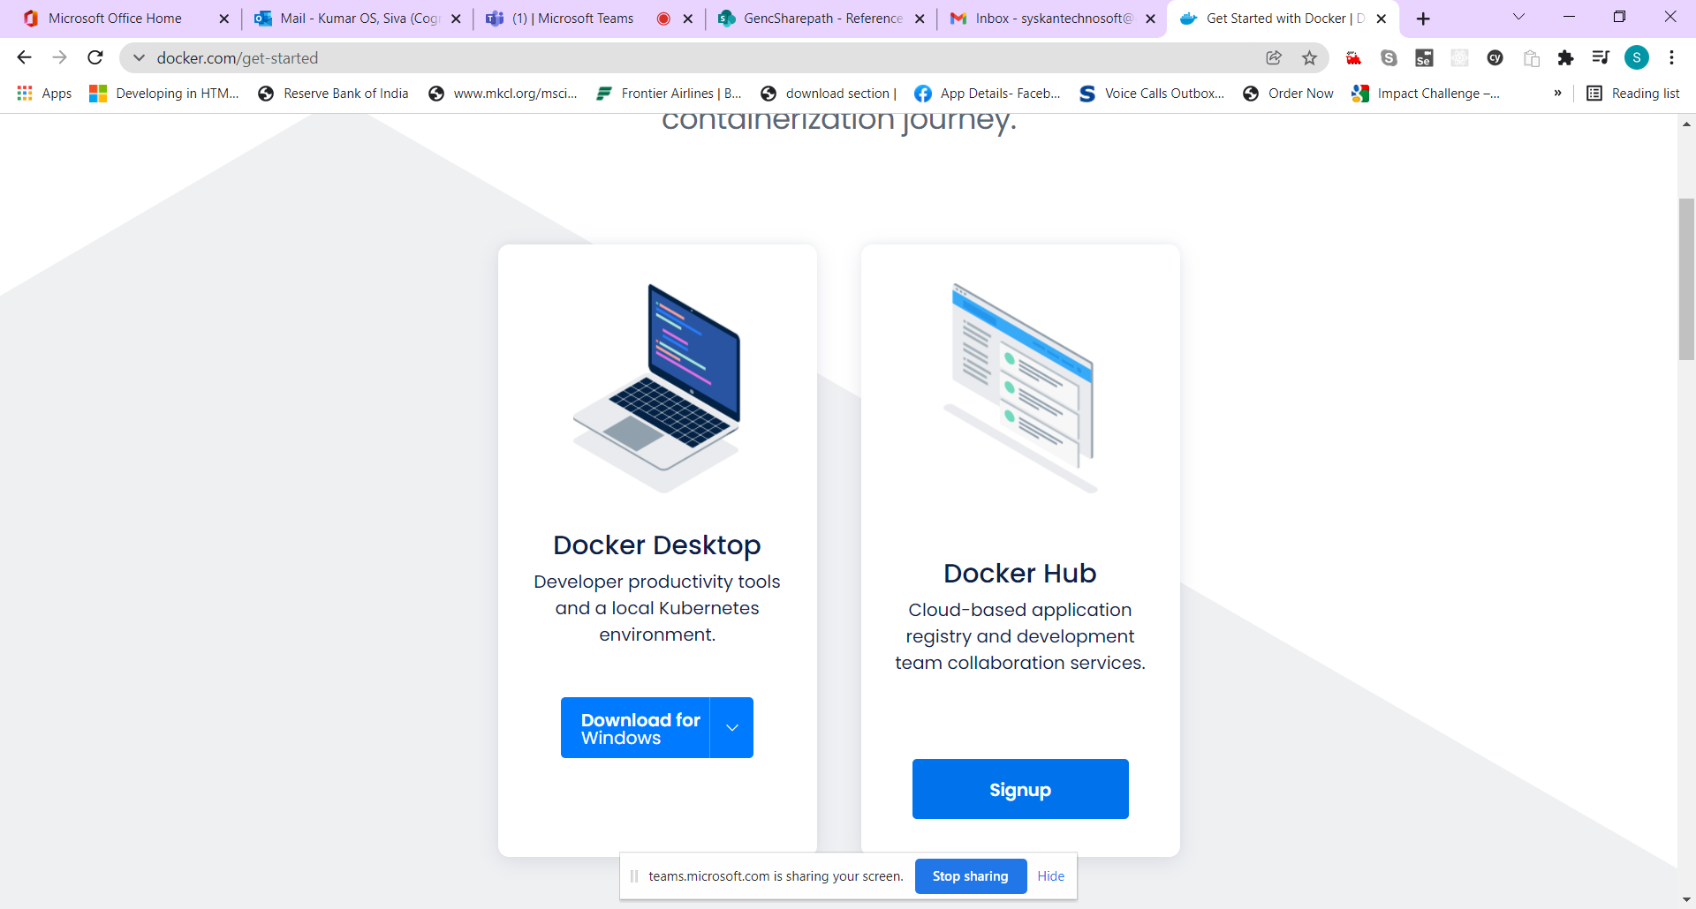

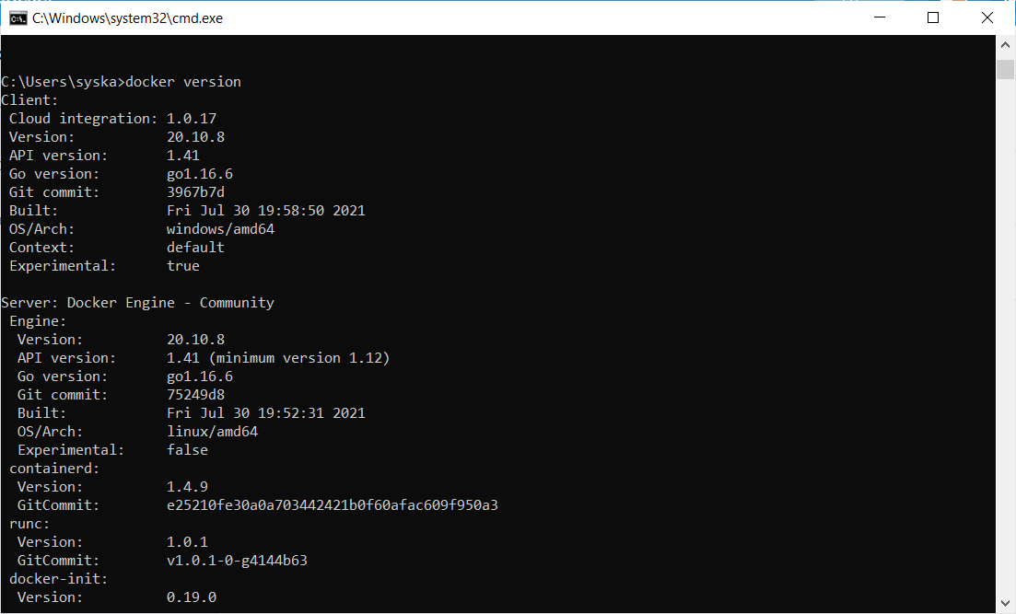

Docker Desktop Dashboard

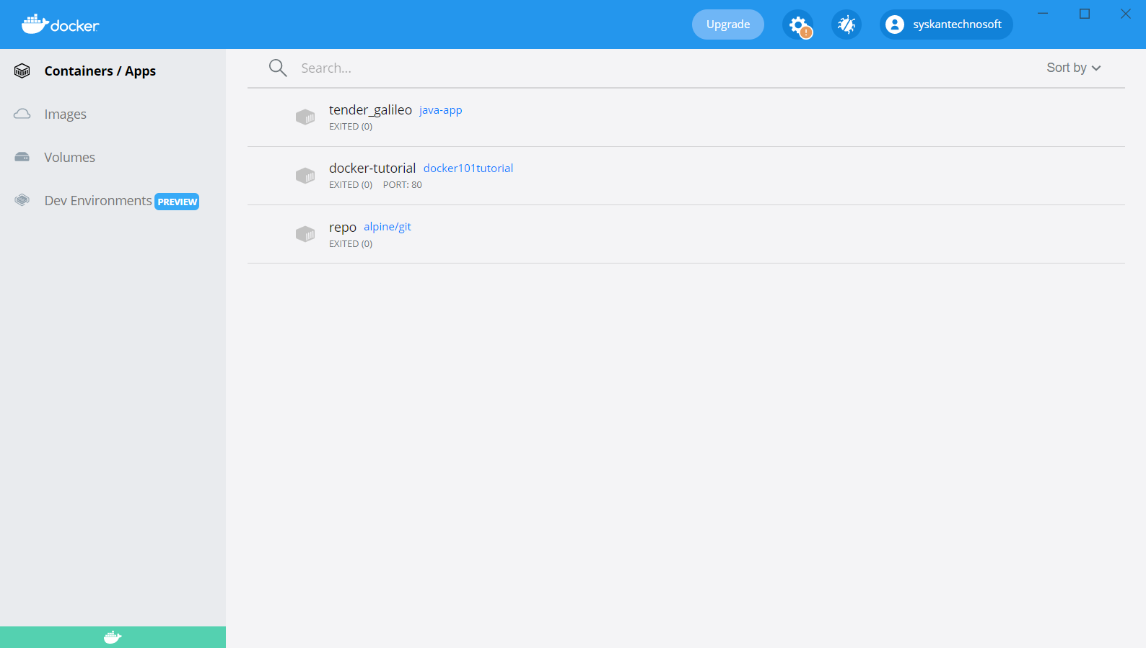

docker run -d -p 80:80 docker/getting-started

80:80 (base OS/Host OS : guest OS/Container )

Images - they are compressed form of the entire application along with all supporting libraries.

Containers – Running instances of images.

Single Image --- It can create n number of containers. (Class --- Objects)